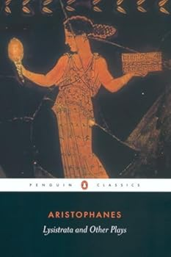
Al Rosenblatt Presents
ARISTOPHANES ACHARNIANS
Winner First Prize, Lenaia Festival
FRIDAY 10 OCTOBER 2025 at 2 PM
ATHENA GYRO TAVERNA
1167 State Route 55, Lagrangeville, NY 12540

THE SCENE
Athens, The Pnyx and Elsewhere, 425 BCE

THE CAST (Subject to Substitution)
Dikaiopolis………………………………………………………………………………………Al Rosenblatt
Crier, Xanthius, Euripides’ Servant, Theban, Messenger #1……………..Robert Cutler
Theorus, Wife, Megarian’s Daughter #1, Bridesmaid………………… …Julia Rosenblatt
Ambassador, Euripides, Megarian, Messenger #2……………………………Paul Kane
Chairman, Daughter, Lamachus, Megarian’s Daughter #2………………….Roger Christenfeld
Pseudartabas, Informer #1, Informer #2, Bridegroom’s Servant……..Mark Villanti
Amphitheus, Nicharchus, Dercetes………………………………………………..Roger Hendricks Simon
Lamachus’ Servant, Messenger #3………………………………………………...Aaron Colton
Chorus…………………………………………………………………………………………..Rachel Kitzinger
Leader…………………………………………………………………………………………..Linn Cary Mehta
Stage Directions………………………………………………………………………………Gully Stanford

RUN OF THE SHOW
2:00 PM Welcome and Introductions (Al Rosenblatt, Rachel Kitzinger)
2:15 PM The Acharnians, an informal reading…approx. 1 hr 40 mins with no Intermission
4:00 PM Talk Back
5:00 PM End of Show

Aristophanes Lysistrata and Other Plays, Penguin Books, Ed. Alan Sommerstein, Revised Edition 2002

